Renewable Power Centred Intelligent Power Supervision System for Households

1K.P. Sherin, 2V. Shijoh and 2T. Jarin

1Department of Power Electronics, Jyothi Engineering College, Kerala, India
2Department of EEE, Jyothi Engineering College, Thrissur, Kerala, India

Abstract: The foremost problem correlated with Indian power grid system is disproportion of consumption of energy and power generation. The problem faced in this modern era is load shedding and power drop.Cuts lead to discomfort to the consumers. The proposed system comforts the consumers for an optimal use of energy. The system is installed in every homestead and with the help of photovoltaic system solar energy is stored for future use. The system analyses the user data utilization using smart meter. From the analysed data the system will foretell the userbehaviour at that time and maintain battery power for use at the time of peak hours so that this will reduce the utilization from grid during peak hour. The system also maintains back power and uses it during power failure and will prioritize the devices for the utilization of stored power.

Key words: Renewable power Smart meter Powergrid Battery management system User
consumption data

INTRODUCTION natural disasters, heavy cyclones etc. Problems in generating station also lead to power failure and isolation
Matching of supply and consumption of power is the of places. So on integrating renewable energy to grid at central challenges faced by Indian power grid system. distribution level or in each house we can meet the lack of Traditional approaches of building enough generation power their by eliminate black outs up to a level and transmission capacity to meet peak load has resulted Government agencies like KELTRON, ANERT are helping in substantial infrastructure that is idle for all but a few people to install the power generators at consumer side. hours of a year. But the main problem is that the proper use of generated In India, traditional method of power supply is power. So energy management technique is very essential following. But this method is fulfilling only the basic small and a system which will dynamically choose either power local needs. The unbalancing of power generation and from grid or from renewable source. According to its demands requires rethinking of traditional method in order availability. And the system automatically control the to compensate for growth in power demands of India’s usage of power from according to the priority of devices power supply. Uses of electromechanical relays are not an which is set either by user or based on consumption and
effective method to find out line faults at distribution side. availability of power[3].
Detection of line faults is presently a time and man power A non renewable energy resource comes from coal, consuming process. oil etc. These will create pollutions and leads to global Up to 2013 January 211.766 GW of electricity has warming and also once the source of non-renewable
been installed. Out of this 11.45% contributed by energy gone out that can’t be reproduce. Renewable renewable power plant and rest is by non renewable energies such as wind, solar etc. will not produce any power plant. This lack of instalment on renewable power pollution. But the main problem is that the difficulty to leads to India to depend on foreigners for energy. And integrate with the grid which leads to voltage level about 300 million Indians have no access to electricity as fluctuations, change in frequency, harmonics etc.[4]
of December 2011. Many of rural areas of India are not Several studies and works has been done in the area
electrified yet and already electrified areas are facing the of renewable energy integration with the grid and the lack of sufficient power. In 2012 power blackout put energy management. This section describes some of the northern states in dark about 3 days [1][2]. Villages major works in this area. Real time pricing –based power andcities may isolated from grid during situations like scheduling scheme as demand response for residential

Corresponding Author: K.P. Sherin, Department of Power Electronics, Jyothi Engineering College, Kerala, India.

power usage is a scheme includes an energy management used either by households to plan their usage or by the controller and a service provider. The provider sets the automatic load control systems for scheduling real time prices according to the current power usage appliances.[12-15]
profiles of the appliances.The energy management The proposed system which helps to optimal use of controller (emc) uses the electricity prices and user power from renewable energy source. The system is preferences to modify power usage across a home or a installed in each house and with the help of a photo building.A sequential equilibrium is attained through a voltaic system which generates power from solar energy two way information exchange enabled through smart and stores for future use. Then the system collect user metering network. The emc aims to minimize the cost to consumption details using smart meter and do the data the consumer for an appliance usage. Time is divided into analysis for getting the user behaviour. from this analysis slots for scheduling updates.This scheme can reduce system will predict the user consumption behaviour and peak load and the mismatch between actual load and use battery power during peak load times, so that planned supply, while avoiding a rebound peak.[5] dependency from the grid can be reduced. The system will An intelligent HEM algorithm for managing high also keep sufficient back power for using at the time of energy consumption household appliances with power failure and will prioritize the devices for the
simulation for demand response analysis is proposed. The consumption of stored power. algorithm manages household loads consumption below
the preset value. System Architecture: The main objective of this work is The HEM system will monitor and manage the home to build a system that is efficient for use of renewable appliances and providing load shifting and shedding power and it can be minimize the dependency of power according to a predefined set of requirements.The HEM from grid and provide continuous operation to certain receives external signals which includes demand devices during power failure. The system mainly consists curtailment request and duration of its algorithm is of relays, microcontroller unit (MCU). Grid power and designed to guarantee the total household power battery power stored from renewable source are given to consumption below the specified demand limit. The home the control devices which will intelligently perform the owner can set their load priority and comfort preferences. distribution of power. The control device connects the A simulation tool is developed in C++ that consists of the smart meter and the distribution board for intelligent proposed algorithm[6-8] power distribution. The loads in each houses are FEDRP is integrated for managing the loads classified into heavy load, low load and critical load on intelligently by using the platform of smart grids for the basis of wattage rating of each device. This is done
residential network. It provides detailed modelling and for the proper energy management.
analysis of respective demands of residential consumers. At the initial stage the stored power will be In a RAN there is energy manager called REM which intelligently distributed based on the decision and communicates with HEM through smart meters. During prioritization algorithms stored in the system. In the later peak hours backup plants are used to accommodate peak stage with the help of the collected consumption details loads which incur extra cost to the consumer. The and various system will dynamically set the priority for consumer is provided same price up to a particular load device to use the renewable power to ensure the above which energy is priced more. Also incentives where continuity of service and the use of the stored renewable offered end users for cutting down their loads during peak power at proper time to use them efficiently and thus to hours. Utility revenue and profit is modelled for different reduce the dependency of power from grid. We assume levels of consumption.[9-11]. that the system will get the user consumption detail from Demand Response program encourage end-use the smart meter installed in the house. In this system, the customers to alter their power consumption in response smart system (control device) will choose the power to incentives or real time electricity prices so that demand source for the usage of loads based on the data analysis. may be reduced. They present a Yupik, a system that For example, the system analyses by establishing the helps the users respond to real-time electricity prices consumption of the critical, heavy and low loads and while being sensitive to their context and lifestyle. Real which available power sources (e.g.: renewable resources time prices are generally published by utilities in advance or grid power) each load is dependent on. From this or can predict for the next couple of days as in. Yupik is analysis, the system can predict the usage of loads and essentially a planner that uses variable hourly prices and the risk of lack of power in the storage device or the extra computes optimal appliance usage schedules for the next energy required during peak hours. To reduce the planning horizon. The generated schedule can then be dependency of power from grid, consumption is

regulated. This is achieved by analysing which type Circuit Description: The basic circuit of the (critical, heavy and low) of load uses the most power in microcontroller consist of a power supply unit, External each house. If a home‘s consumption is increasing the Crystal oscillator and a reset circuitry. The power supply system will decide to depend on their available quota of consist of a voltage regulator which is used to regulate renewable resources than the grid power. For example, the voltage to a fixed voltage of 5v.Normally 7805 voltage there may be medical devices needing an energy supply regulators are used for this purpose. The A C voltage is
24/7 (thus deemed as a critical load), these high priority step downed using a transformer and a bridge rectifier is
devices will consume more power and require continuity used to convert AC to DC this rectified DC is passed of service. Therefore when energy is scarce (i.e.: at the through a capacitor filter and fed to the voltage regulator. time of power failure or when total consumption is Normally the crystal oscillator provided with the increasing), the system will automatically give priority to microcontrollers is of 16MHz and to 22pf capacitors are medical devices by designating most of the renewable used with the microcontroller as decoupling capacitors for power to critical loads. Thus prioritization is achieved decreasing the noise. The reset circuitry used here consist automatically based on the data analysis. of a switch and a resistor normally a HIGH signal is present in the mCLR pin of the microcontroller when the
Block Diagram and Circuit Description. switch is pressed a LOW presents at the pin and Block Diagram: The basic system model includes a microcontroller gets reset and as there is a resistor microcontroller unit, an RF module, pc, current sensors provided in circuit the Vcc and Ground never get direct and relay driver. The current sensors sense the currents short while resetting. The microcontroller consists of an of each load and also the current in both the ac mains internal ADC module this ADC module is used to convert and the battery source and transfers the data to the ADC reading from the sensor to a digital value. The microcontroller unit. The pc stores and analyses user ADC provided with microcontroller is of 10 bit resolution. consumption details such as average power consumption This reads value from 0- 1023.The Devices which output of each unit of loads. This data is transmitted to the the analogue variation can communicate with controller microcontroller unit through the RF data modem. using this module.
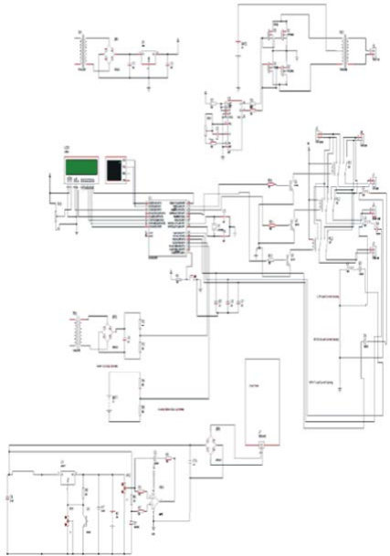Depending on the data the microcontroller generates suitable signals to the relay driver so that the relay of each unit of loads is switched either to ac mains or to the battery power.
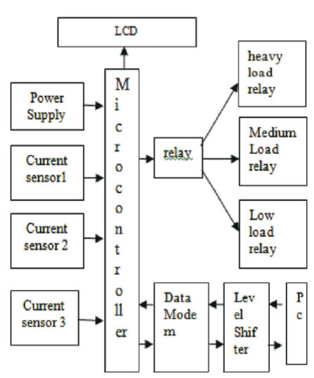

Fig. 1: Block diagram of intelligent power management Fig. 2: Circuit diagram of intelligent power management system system

The current transformers are coupled with a bridge data. The data lines are connected to a port of the rectifier and a filter this output is sampled using a voltage microcontroller and the control lines RS (register divider is connected to the analogue input pin of the select), E (enable), R/W (read /write), are connected to the microcontroller. The voltage is also measured using the corresponding pins.
same circuit as the current sensing circuit; instead of The Solar charger consist of a rectifier and a voltage current this circuit uses a step down transformer for regulator LM 317 the lm 317 is a variable voltage regulator getting the sample voltage from mains. the output voltage is set by using a voltage divider circuit The inverter circuit consists of CD4047. It is a multi in adj pin of the voltage regulator. The lm 358 op amp vibrator with very low power consumption designed by based cut off circuit is included with charger for
TEXAS INSTRUMENTS. It can operate in monostable overvoltage cut off. multivibrator and also astable multivibrator. In the astable
multivibrator mode it can operate in free running or Hardware Design and Algorithm
gatable modes and also provides good astable frequency Hardware: The renewable resources considered in this stability. It can generate 50% duty cycle which will create project are solar power. The system will dynamically a pulse, which can be applied for inverter circuit. This is manage the electricity utilization with respect to a few mainly used in frequency discriminators, timing circuits parameters such as the availability of renewable frequency divisions etc. IRFZ44 is a N-channel enhanced resources, priority of devices, peak hour timings. The total mode silicon gate field effect transistor (MOSFET).they load in a system is classified into three -critical, low are mainly used in switching regulators, switching and heavy, based on the wattage consumption. The converters relay drivers etc. the reason for using them in controller will receive the current consumption from the inverter circuit is the because it is a high switching the current sensors and the current time (peak or off transistor, can work in very low gate drive power and peak hours) from the real-time clock (RTC) and send have high input impedance.IC CD4047 will work in the this data to the controlling station, via RF module for load astable multivibrator mode. To work it in astable to battery power or AC mains as per the instruction from multivibrator mode we need an external capacitor which the MCU. The relay driver amplifies the current received should be connected between the pin1 and pin3. Pin2 is from controller that will initiate the working of the relay connected by the resistor and a variable resistor to system.
change the change the output frequency of the IC. The power supply will not be interrupted during the Remaining pins are grounded.The pins 10 and 11 are switching since the relay system works with in a fraction connected to the gate of the MOSFETs IRFZ44. The pin of seconds. The display device will display the connected
10 and 11 are Q and ~Q from these pins the output load and the mode of operation. With the help of a keypad frequencies is generated with 50% duty cycle. The output device, the user can select the mode of operation and the frequency is connected to the MOSFETs through resistor type of loads that is to be operated with the battery which will help to prevent to the loading of the MOSFETs. power. Thus with the help of user interface, the consumer The main AC current is generated by the two MOSFETs can select either manual or automatic mode. In manual which will act as a two electronic switches. The battery mode, the user can select the load to switch to the battery current is made to flow upper half or positive half of the power. And in the automatic mode, the system will get the primary coil of transformer through Q1 this is done when peak hour from the smart meter and will perform as per the the pin 10 becomes high and lower half or negative half is algorithm stored in MCU i.e., as per the previous done by opposite current flow through the primary coil of agreement with the consumer or according to the transformer, this is done when pin 11 is high. By behaviour of the consumer. The previous agreement switching the two MOSFETs current is generated. This between the consumer and utility takes into account the AC is given to the step up transformer of the secondary total load that can be connected, the peak hour etc. So coil from this coil only we will get the increased AC depending on the time and the consumption of power, the voltage, this AC voltage is so high; from step up system will look for the battery power. And if the battery transformer we will get the max voltage. power is enough to run a particular type of device (critical, The LCD is an external module used to display the heavy or low) then the system will switch to the stored details to the user. The LCD communicates with the power for the use of that particular device with the help of
microcontroller using parallel communication of the relay systems.

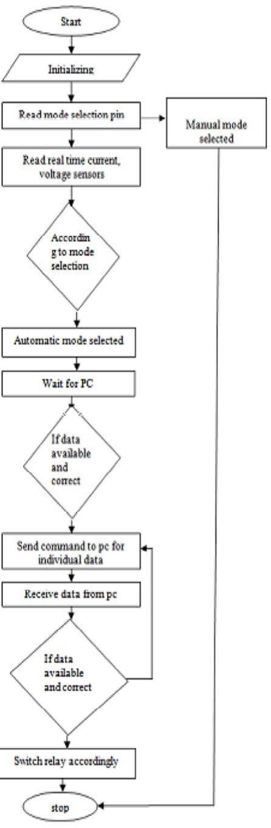Algorithm: The algorithms discussed are for testing the basic capabilities of the system, such as decision making: if the consumption is more during peak hours, less storage power, storage is full; AC power is not available and varying battery power. The relays in the system, will select the power source for devices as per the instructions from MCU based on the total consumption and time. The threshold for total consumption of loads for each consumer is set based on the slab (allowable usage for consumers as decided by the authorities). The threshold we chose is less than the slab for every consumer, because by selecting the threshold under the slab we can reduce the consumption from AC mains. The system will get the total consumption and the time from the RTC and sensors (or from smart meter). Then the system will check for the peak time, if the time is peak time and the battery is charged from the renewable resource has power, (more than 50 percentage of its capacity) to drive the devices in use, then the relay system will select the power source as battery power. The different cases for which the proposed algorithm works to test the basic capabilities of system are shown below.

Case 1: In the case of automatic mode of operation and the time is peak hour, then the system will look for the total consumption of loads. If the total consumption exceeds the threshold, then the system will check the battery power. If battery power is enough to run the critical loads, then the system will select the source for critical loads as battery power. If battery power is not enough to run the critical loads, then it will go for the heavy load and then for the low load. And the system will use the battery power till the battery power reaches 30 percentage of maximum storage. This is because we need to keep some back power for our use if a power failure
occurs.

Case 2: In the case of automatic mode of operation and if the battery is fully charged, then the system will use the
battery power for critical loads, till the battery power Fig. 3: Flow chart reaches 80 percentage and then grid power iarts used for
critical loads. Implementation and Test Results: We implemented our system in a test bed with some appliances connected. The
Case 3: In the case of automatic mode of operation and if appliances includes three bulbs of 100W (heavy load), AC power is not there then the system will use the battery 60W (medium load) and 40W (low load)in Matlab Simulink power to critical loads as these loads have high priority. (shown in Fig. 4), by taking one of the inputs to power Case 4: In the case of Manual mode of operation the user source as stored power from the photovoltaic system and can select the source of power for certain types of loads other source as power from grid. and synchronised (critical, heavy etc.) voltage and current obtained.

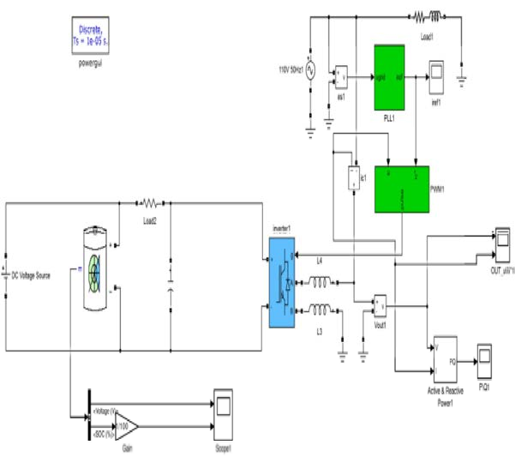
Fig. 4: Simulink model of synchronization of grid and battery supply.

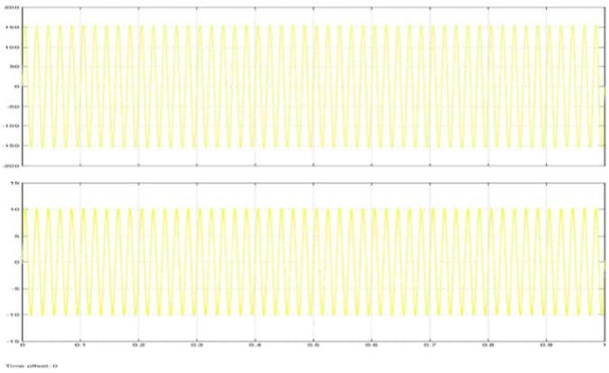

Fig. 5: Synchronised voltage and current

CONCLUSIONS dependency ofpower from grid means more consumers can be put on the grid so that electrification in India
The proposed energy management system that will canbe completed. We implemented our system in a help to use the stored renewable power efficiently, there test bed and some basic system capabilities issimulated by dependency of the power from grid especially during in Matlab Simulink also, the results show that peak hours can beminimized and result in reduction in the dependency on power from the grid canbe reduced to electricity bill of consumer. The system also maintains 70-80% during peak hours, resulting in the reduction of continuity of service for devices during power failure with the average daily consumption to less than 30% of normal high priority and the priority ofdevices will dynamically consumption by using the stored renewable power change with respect to the user behavior. Thus reducing atproper time.

REFERENCES |  | 9. | Muhammad Ali1, Z.A. Zaidi2, Qamar Zia1,
 |  |  | M. Zakaria1, S.M. Ahsan1 and M. Rameez, 0000.
1. | All India region wise Generating installed capacity of |  | Intelligent Load Management Scheme for a
 | power. Central electric authority, Ministry of power, |  | Residential Community in Smart Grids Network Using
 | Government of India. January 2013. |  | FEDRP: WSEAS Transactions On Power Systems.
2. | Power Grid Corporation of India Limited. Our | 10. | Vuppala, S.K., K. Padmanabh, S.K. Bose, S. Paul,
 | Network April 2013 http://www.powergridindia.com |  | 2011. Incorporating fairness within Demand response
 | / _ l a y o u t s / P o w e r G r i d / U s e r / C o n t e n t P a g e . |  | programs in smart grid, in Proc. IEEE Innovative
 | aspx?PId=80&LangID=English |  | Smart Grid Technologies (ISGT), pp: 1-9.
3. | For India, a Power Failure Looms. The Wall Street | 11. | Ghosh, S., X.A Sun and Xiaoxuan Zhang, 2012.
 | Journal. 2 January 2012. |  | Consumer profiling for demand response programs in
4. | Aryadevi, R.D., S. Anilesh, Fabien Robert and |  | smart grids, in Proc. IEEE Innovative Smart Grid
 | Maneesha V. Ramesh, 2013. Smart Device for |  | Technologies - Asia (ISGT Asia), pp: 1-6.
 | Optimal Use of Stored RenewablePower: IEEE 7th | 12. | Tanuja Bapat, Neha Sengupta, Sunil K. Ghai, Vijay
 | International Power Engineering and Optimization |  | Arya, Yedendra B. Shrinivasan and Deva Seetharam,
 | Conference, June 2013. |  | 2009. User-sensitive Scheduling of Home Appliances:
5. | Chen Chen, Shalinee Kishore and Lawrence V. |  | Journal of Computing and Information Science in
 | Snyder, 2010. An Innovative Rtp-Based |  | Engineering, 9: 1-9.
 | Residential Power Scheduling Scheme ForSmart | 13. | Adika, Christopher O. and Lingfeng Wang, 2014.
 | Grids: IEEE Trans. on Smart Grid, 1(2): 120.133. |  | Smart charging and appliance scheduling approaches
6. | Manisa Pipattanasomporn and Murat Kuzlu, 2012. |  | to demand side management, International Journal of
 | An Algorithm for Intelligent Home Energy |  | Electrical Power and Energy Systems, 57: 232-240.
 | Management and Demand Response Analysis: IEEE | 14. | Lijesen, Mark G., 2007. The real-time price elasticity of
 | Transactions on Smart Grid, 2012. |  | electricity, Energy economics, 29(2): 249-258.
7. | Piette, M.A., D. Watson, N. Motegi, S. Kiliccote | 15. | Rasheed, Muhammad Babar, NadeemJavaid, Ashfaq
 | and E. Linkugel, 2006. Automated demand |  | Ahmad, Zahoor Ali Khan, Umar Qasim and Nabil
 | response strategies and commissioning commercial |  | Alrajeh, 2015. An Efficient Power Scheduling Scheme
 | building controls, Proc. 14th Natl. Conf. Building |  | for Residential Load Management in Smart Homes,
 | Commissioning, 2006-Apr. |  | Applied Sciences, 5(4): 1134-1163.
8. | Du, P. and N. Lu, 2011. Appliance commitment for
 | household load scheduling, IEEE Trans. Smart Grid,
 | 2: 411-419.

